**KNAPSACK PROBLEMS**

0-1 knapsack says that we can either include or not include an item completely.

Fractional knapsack says that we can include a part of an item. (greedy approa.)

Unbounded knapsack says that we can include an item multiple times in the bag

1) Choice is given in inputs.

2) Optimal sol neg max, min.

Choice diagram is made.

We have 2 options, either the object weight is greater than bag weight (in that case we have 1 choice to not include) or it is less than the bag weight (in that case we have 2 choices, to include or not).

In recursion we try to call a smaller case. We start from the last and check for it and decrease n.

Recursive solution:

N is number of items in wt array and W is the weight allowed.

Int knapsack(int wt[], int val[], int w, int n) {

**Base condition (think of the smallest valid input)**

If(n==0 || w==0) // n 0 means no item, and w 0 means no capacity so profit is 0 in both case hence valid but useless

Return 0;

**Choice diagram**

If(wt[n-1] > w) // if wt is more than allowed don’t take

Retrun Knapsack(wt,val,w,n-1);

Else // else take max of either including or excluding

Return max(Knapsack(wt, val, w-wt[n-1],n-1),Knapsack(wt,val,w,n-1));

};

**Memoization**

We make the matrix for those variables which are changing, i.e. w (capacity) and n (size of wt array).

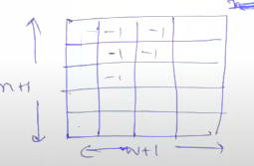

Int t[n+1][w+1]

Memset(t,-1,sizeof(t))

Before calling the recursive function, we check whether the value is present or not. (if not it will be -1)

Memoized code

Int t[n+1][w+1]

Memset(t,-1,sizeof(t))

Int knapsack(int wt[], int val[], int w, int n) {

**Base condition (think of the smallest valid input)**

If(n==0 || w==0) // n 0 means no item, and w 0 means no capacity so profit is 0 in both case hence valid but useless

Return 0;

**Memoized check**

***If(t[n][w] != -1)***

***Return t[n][w];***

**Choice diagram**

If(wt[n-1] > w) // if wt is more than allowed don’t take

Return ***t[n][w]*** *=* Knapsack(wt,val,w,n-1);

Else // else take max of either including or excluding

Return ***t[n][w]*** = max(Knapsack(wt, val, w-wt[n-1],n-1),Knapsack(wt,val,w,n-1));

};

**Dynamic programming**

Better than recursion because it prevents stack overflow error (the stack which holds recursive function call).

Step 1 – Initialisation

Step 2 – Change recursive call to iteratives

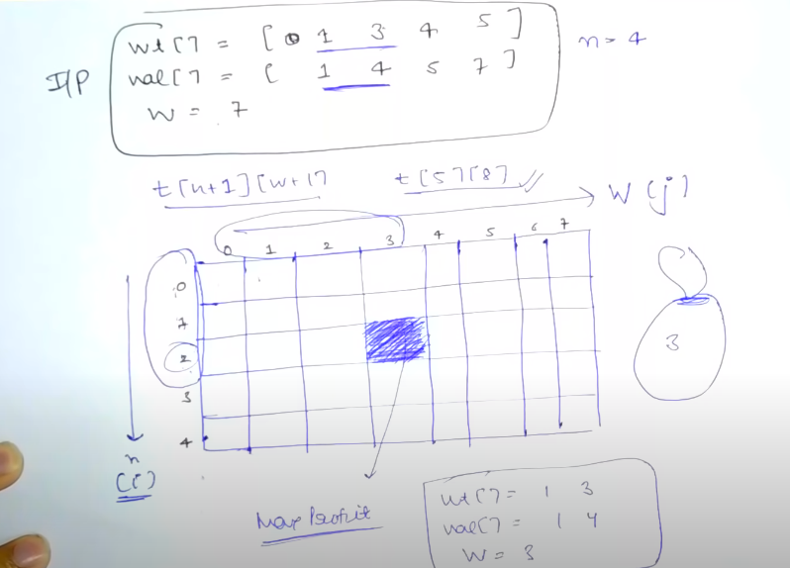

The block represents maximum profit when value array has 2 values and max weight allowed = 3.

**Initialisation**

The recursive problem base condition changes to the dynamic initialisation.

Initialise the first row and column of the dp as 0.

**Iteration**

Recursion calls are changed to iteration.

If(wt[n-1] > w)

Return knapsack(wt,val,w,n-1)

Else

Return max(knapsack(wt,val,w-wt[n-1],n-1),knapsack(wt,val,w,n-1))

If(wt[n-1] > j) // here j represents the allowed weight

T[n][w] = t[n-1][w]

Else

T[n][w] = max(val[n-1] + t[n-1][w-wt[n-1]], t[n-1][w]);

**Subset sum problem**

Find a subset in the array whose sum is equal to the given sum.

The similarity here is that we have to decide whether we should take the element or not.

Arr[5] = 2,3,7,8,10

Target = 11

Int t[6][12]

The rows basically tell us the size of the array.

The first row tells that no elements are present.

The second row tells 1 element is there.

It is possible to obtain the sum 0

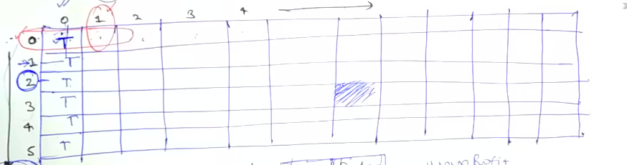

For first row apart from first column (sum 0) it is not possible to obtain any sum using an empty array which has 0 elements as denoted by the column.

If(arr[i-1] <= j)

T[i][j] = t[i][j-arr[i-1]] || t[i-1][j] // taking the number or not taking

Else

T[i][j] = t[i-1][j]

**Equal sum partition problem**

We have to tell true/false whether the array has subset sum equal.

We first check whether complete sum is even or not. If odd then not possible.

If even then we divide it into 2 and then repeat subset problem.

**Count of subsets sum with a given sum**

The initialisation is same as subset sum problem with the difference that instead of true false we have 1 0.

The only difference is instead of using or we use +.

If(arr[i-1] < j)

T[i][j] = t[i-1][j] + t[i-1][j-arr[i-1]];

Else

T[i][j] = t[i-1][j];

**Minimum subset sum difference**

Similar to equal sum partition.

We have to minimise s1-s2.

Also s1+s2 = range.

Hence we minimise range – 2s2.

So we use the subset sum problem and calculate that which all sum can be obtained using all the possible subsets.

Then we divide the final sum into half and take the first half possible elements.

Finally we take a variable to calculate the least diff.

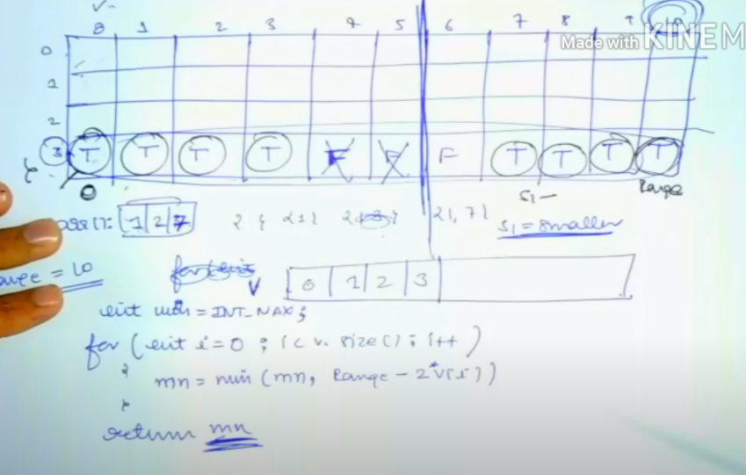

**Count the number of subset with a given difference**

Find (number of) two subsets such that their difference is given to a particular.

We have to find sum(s1) – sum(s2) = difference

Also sum(s1) + sum(s2) = sum of array

Sum1 = (sum of array + difference) / 2

Both are given hence this reduces to a count of subset sum problem.

Therefore, find count of subsets having sum equal (array+difference)/2.

**Target sum problem**

We have to assign signs to the subset numbers so that the sum is given.

Eg if we are given 1 1 2 3 and target sum = -1.

Assign -1 +1 +2 -3. Net sum -1.

Hence this becomes

Same as the last problem where we divide the array into two subsets to find diff.

**Unbounded knapsack**

Here we can include an item multiple times.

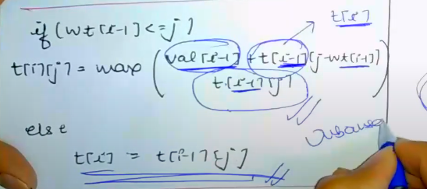

**Rod connecting problem**

We are given total length, array of length cut and price of these cuts.

Length of rod = N

Length cut array contains values from 1, 2…N.

Price array contains value for all these and size is N.

Hence input is 2 array and 1 variable like knapsack.

Here length of rod array = wt array, price = val array and N = W.

We get a choice that whether we should cut it in this piece form or not.

This is unbounded knapsack.

We can cut in form of 2-2-2-2.

T[length+1][n+1] // n= rod length

If(length[i-1] <= j)

T[i][j] = max(price[i-1] + t[i][j-length[i-1], t[i-1][j]);

Else

T[i][j] = t[i-1][j]

**Coin change problem (max ways)**

We have to use the coin array to get a particular sum and any coin can be used multiple times.

Here sum = w (of knapsack)

Coin array = weight array

No second array.

T[n+1][w+1]

If (coin[i-1] <= j)

T[i][j] = t[i-1][[j] + t[i][j-coin[i-1]]; // here number of ways so + instead of max // we use t[i][j-coin[i-1]] because it is unbounded knapsack and hence if we have used it we can use again

Else

T[i][j] = t[i-1][j];

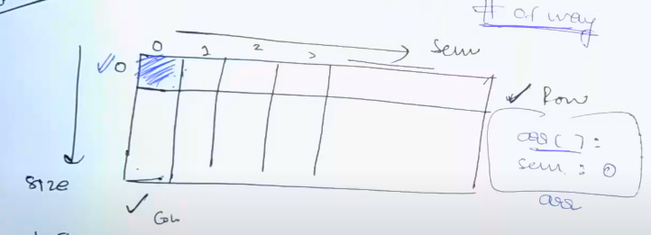

First row is initialised as 0 because with 0 size we cannot get sum.

First column will be 1 because we can get sum 0 from empty array.

**Coin change problem (min coins)**

Here the first row is initialised with INT_MAX-1 because we need these many coins to get the required sum if the given array is empty.

The first column is filled with 0 because we need 0 coins to get sum as 0.

The second row is initialised depending on whether the weight is divisible (j) by the first element of the coin array.

For eg if we have coin array [3,5,2] and weight as 8.

Then second row is initialised as 0,max,max,1,max,max,2,max,max.

If(coin[i-1] <= j)

T[i][j] = min(t[i][j-coin[i-1]] + 1, t[i-1][j]);

Else

T[i][j] = t[i-1][j];

This is because of +1 that we use INT_MAX – 1.

**Longest common subsequence (return length)**

**Recursion**

Base condition

If any length is 0 then common is 0

If(A.length() == 0 || B.length() == 0)

Return 0;

Choice Diagram

If both match decrement both by 1 else make 2 cases and decrement any one of them by 1 in the individual cases.

N = length of string x

M = length of string y

Int lcs(string x, string y, int n, int m) {

**Base condition**

If(n==0 || m==0)

Return 0;

**Choice diagram**

If(x[n-1] == y[m-1])

Return 1 + lcs(x,y,n-1,m-1);

Else

Return max(lcs(x,y,n-1,m),lcs(x,y,n,m-1));

}

**Memoization**

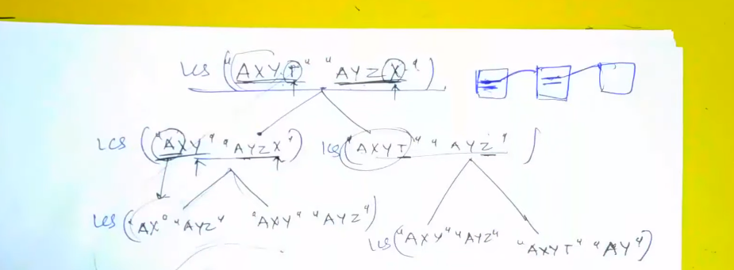

Here we can see that AXY AYZ sub problem is repeated.

Use memo.

Here n and m is changing so the matrix dimensions are n+1 and m+1.

Initialise matrix with -1.

Int lcs(string x, string y, int n, int m) {

**Base condition**

If(n==0 || m==0)

Return 0;

***Memoization***

***If(t[m][n] != -1)***

***Return t[m][n];***

**Choice diagram**

If(x[n-1] == y[m-1])

Return ***t[m][n] =***1 + lcs(x,y,n-1,m-1);

Else

Return ***t[m][n]*** = max(lcs(x,y,n-1,m),lcs(x,y,n,m-1));

}

**Dynamic Programming**

Int lcs(string x, string y, int n, int m) {

Int t[n+1][m+1];

For(int I = 0; I < n+1; i++)

For(int j = 0; j < m+1; j++)

If(i==0 || j==0)

T[i][j] = 0;

For(int I = 0; I < n+1; i++)

For(int j = 0; j < m+1; j++) {

If(x[i-1] == y[j-1])

T[i][j] = 1 + t[i-1][j-1];

Else

T[i][j] = max(t[i-1][j],t[i][j-1]);

}

}

**Longest common substring**

Here the pattern cannot be discontinuous.

Input format is same as we are given two strings.

Output format is same as int is asked.

String is asked instead subsequence.

We set to 0 whenever mismatch.

If(a[i-1] = b[i-1])

A[i][j] = 1+a[i-1][ j-1];

Else

A[i][j] = 0;

**Printing longest common subsequence**

Input is again string.

Question is again LCS type.

Output is different as instead of int we print string.

Hence lcs type question.

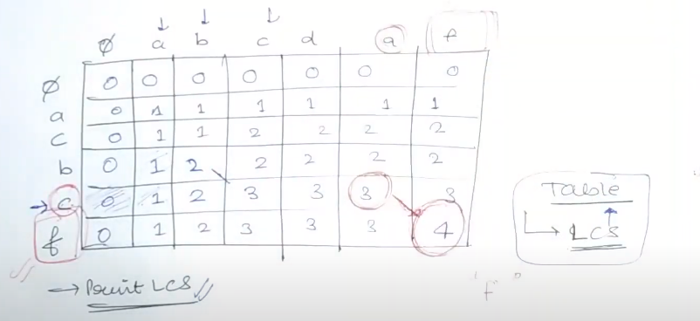

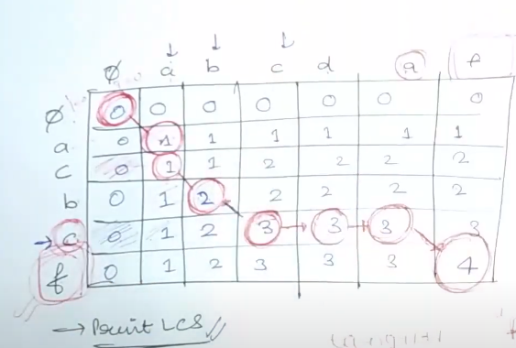

We start from last index and check if its equal or not. If the values are equal we shift to index i-1,j-1 else we shift to the max index of i-1,j or I,j-1.

Repeat until 0.

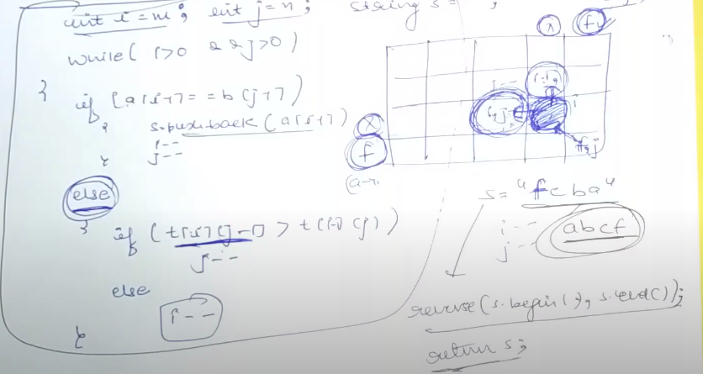

**Shortest common supersequence**

Given two strings let us say geek and eke.

We have to find the shortest string which contains both.

Geeke.

Order should be maintained of the string but continuous not mandatory.

We take the sum of strings and subtract LCS

From it.

**Minimum insertions/deletion to convert string a->b**

Eg string heap and pea is given.

Add p and remove hp to get pea. Hence 3.

Here input is 2 strings, answer required is optimal as minimum hence DP.

If 2 array/1 array and capacity then knap.

If 2 strings and optimal then lcs type.

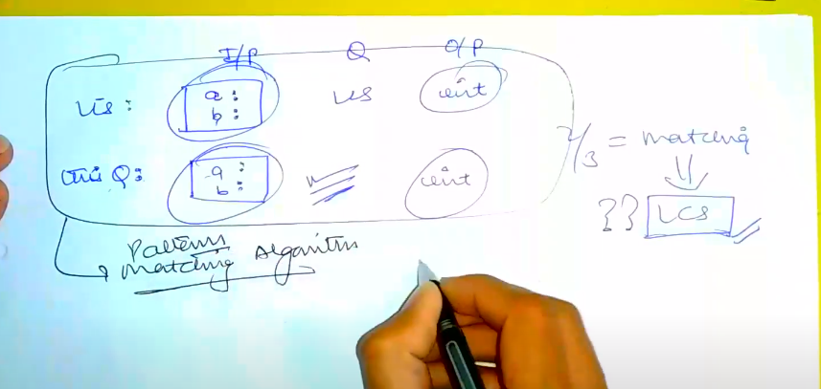

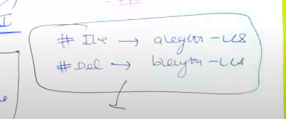

**Longest palindromic subsequence**

We are given a string and we have to return length of longest palindromic.

Here in input we are only given 1 string.

However the second string is generated reverse.

Find LCS of a and b such that their indices are not equal.

**Minimum deletion to make palindrome**

We first calculate the longest palindromic subsequence of the given string,

Using the earlier stated method by finding the LCS of the string and reverse.

Now length of string – Longest palindromic subsequence of the string = deletion.

Eg agbcba, LPS = abcba hence 6-5=1.

**Print shortest common supersequence**

Eg acbcf and abcdaf = acbcdaf.

Hence print acbcdaf.

We have done SCS where printing was done of length scs.

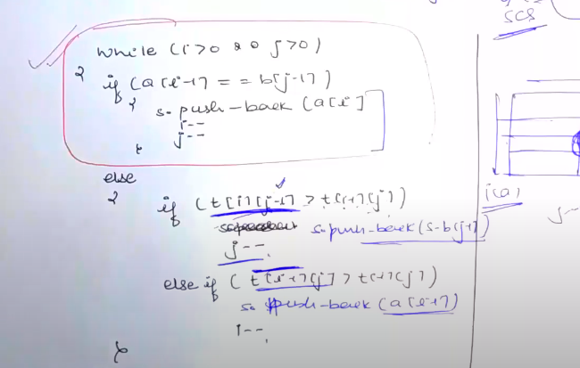

We start from last box and if values are equal we add only 1 of it and then move it to diagonal. Else we move the pointer to the adjacent bigger element and also we add the mismatched characters to the final ans.

However at the end we might not reach the topmost first box.

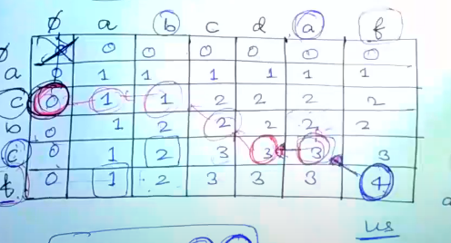

When we reach 0 we have “ac” and “0”. The SCS for this is ac. This is added.

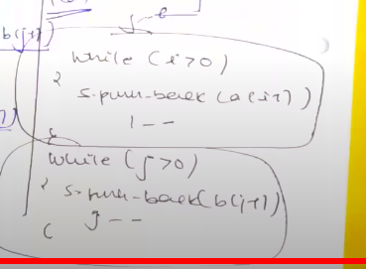

**Longest repeating subsequence**

Aabebcdd

Abd is repeating subsequence.

E and d is not included because it is coming only once.

Hence we take b as same a.

We find LCS but index should not be equal if elements match only then we can include a particular element in both subsequences.

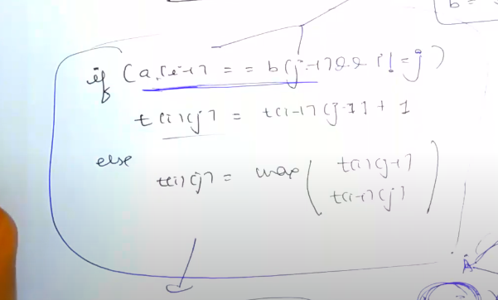

**Sequence Pattern Matching**

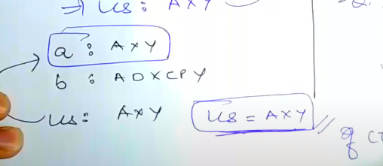

We find LCS and if its equal to a or b then yes pattern is matched.

**Minimum insertions to make a string palindrome**

This is same as number of deletion because instead of deleting we can add those many elements.

Hence this is same as deletion.

**Matrix chain multiplication**

Int solve(int arr[], int I, int j) {

If(I > j) // means no array possible

Return 0;

For(int k = I; k < j; k++) {

Tempans = solve(arr,I,k) + solve(arr,k+1,j);

Ans = max(ans,tempans); // max is just a case

}

}

**Recursion**

We are given an array with matrix dimensions.

Eg 2, 3, 6 means matrix of 2x3 and 3x6.

We can multiply this and their cost will be 2x3x6.

A – 10x30

B – 30x5

C – 5x60

(AxB)xC = 10x30x5 + 10x5x60 smaller

Ax(BxC) = 10x30x60 + 30x5x60

So we decide how to multiply for minimum cost.

Array given = 40 20 30 10 30

A[i] = A[i-1]xA[i]

A1 = 40x20

A2 = 20x30

A3 = 30x10

A4 = 10x30

Step 1: check possible values of I and j.

I min value = 1 and j = size-1.

(Because i-1 = 0 for first index and j is last index of last matrix)

Step 2: Base condition

Step 3: Move k I to j.

First decide values of k.

Step 4: calculate temp ans

**Scheme 1**

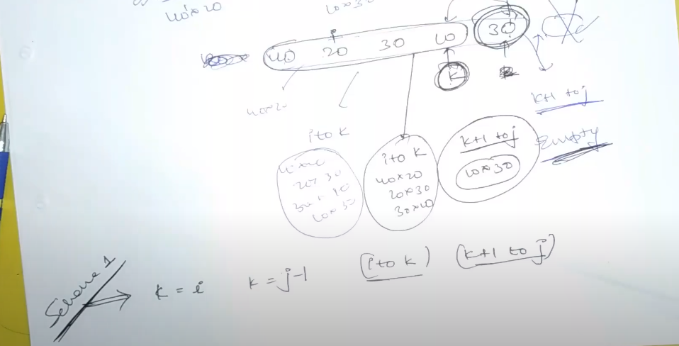

K goes from I to j-1.

40 20 30 10 30 if I = 0, and j = 4…then k should go from I to j-1 and j-1 to j.

So break is from I to k and k + 1 to j.

In I to k we get matrices, 40x20, 20x30, 30x10…now k is pointing to 10 and j to 30. So k+1 to j will give us the matrix 10x30 (because we take j and j-1 for index).

**Scheme 2**

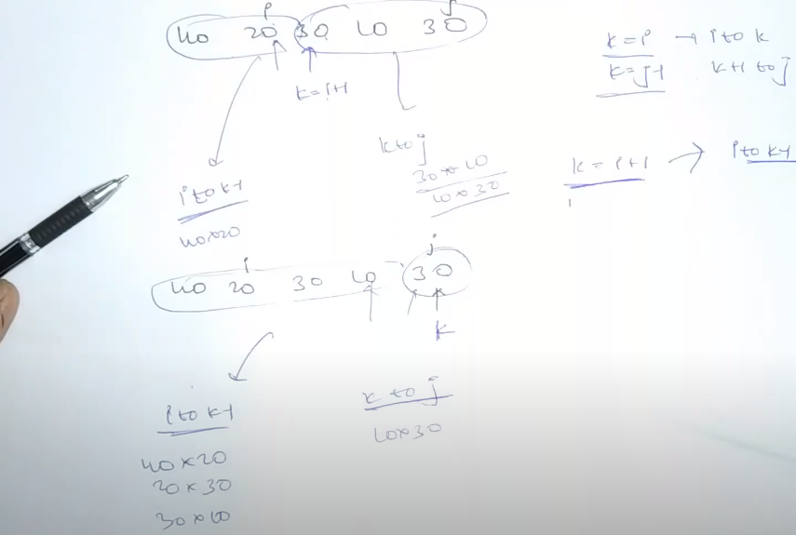

K goes from i+1 to j.

The break is from I to k-1 and k to j.

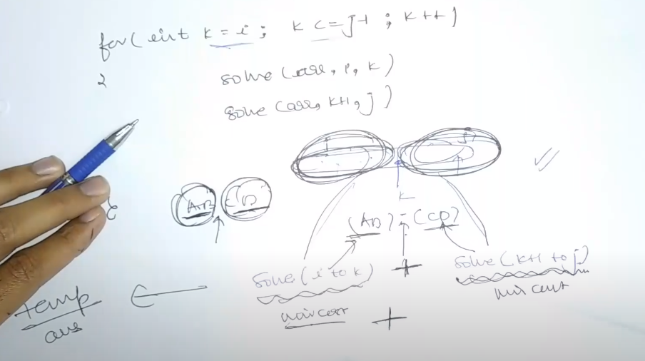

We get cost of AB and CD using the min recursions and finally we need to find their multiply cost.

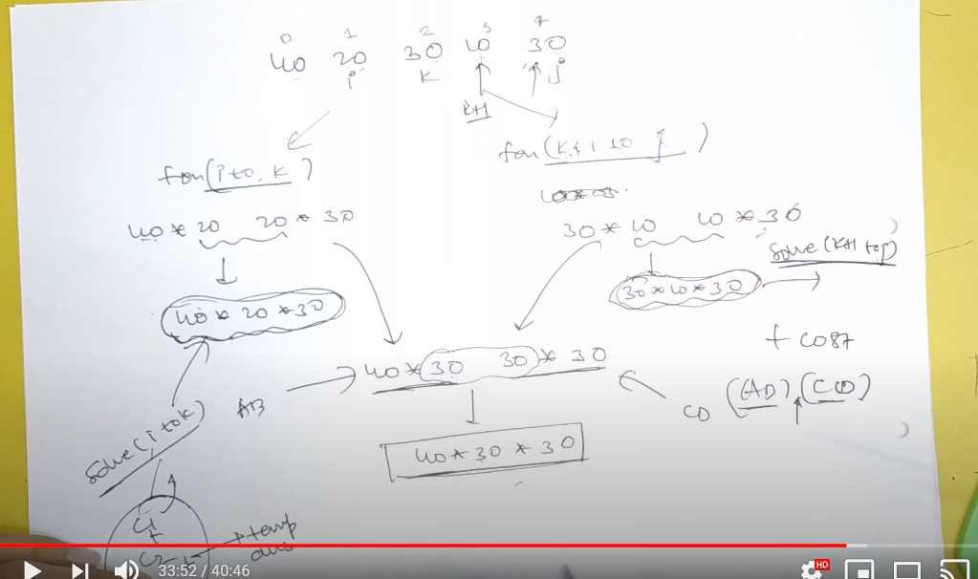

Case…here we see we get k as 30 and we get cost of 2 sub matrices and then their final cost is added using:

Extra cost = 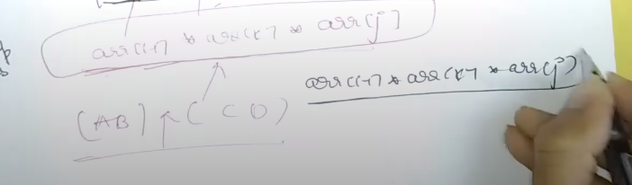

Cost1 = solve(I+1,k)

Cost2 = solve(k+1,j)

Cost 3 = extra cost

Int solve(int arr[], int I, int j) {

**Base condition**

If(I >= j) // size 1 is also not possible because we need 2 indexes for dimension of the matrix

Return 0;

**Move k I to j**

For(int k = I; k <= j-1; k++) {

Int tempans = solve(arr,I,k) + solve(arr,k+1,j) + arr[i-1]*arr[k]*arr[j];

If(temp < mini)

Mini = temp;

}

Return mini;

}

**Memoization**

The variables changing are I and j.

Int solve(int arr[], int I, int j)

Hence we make a matrix of size arr.size()+1.

Int t[arr.size()+1][arr.size()+1];

Int solve(int arr[], int I, int j) {

**Base condition**

If(I >= j) // size 1 is also not possible because we need 2 indexes for dimension of the matrix

Return 0;

***If(t[i][j] != -1)***

***Return t[i][j];***

**Move k I to j**

For(int k = I; k <= j-1; k++) {

Int tempans = solve(arr,I,k) + solve(arr,k+1,j) + arr[i-1]*arr[k]*arr[j];

If(temp < mini)

Mini = temp;

}

Return ***t[i][j]*** = mini;

}

**Palindrome partitioning**

Step 1: Check I and j value

Here I can be index 0 and j can be size-1.

Step 2: if(I >= j) return 0; (this means size of string is 0 that’s why and 1 and in both cases we do not need to do partitioning to make it a palindrome)

If(I >= j)

Return 0;

Step 3: Check value of k

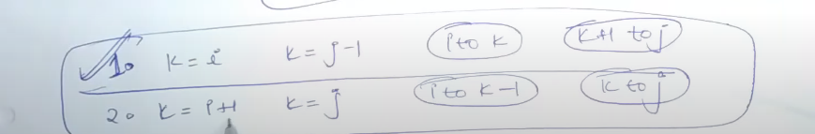

If(I >= j)

Return 0;

If(isPalindrome(a,I,j))

Return 0;

***If(t[i][i] != -1)***

***Return t[i][j];***

For(int k = I; k < j; k++) {

Int temp = solve(a,I,k) + solve(s,k+1,j) + 1; (1 is added because since its not isPalindrome means we divide it at that point and find for rest 2 cases)

Ans = min(ans,temp);

}

Return t[i][j] = ans;

Code of isPalindrome

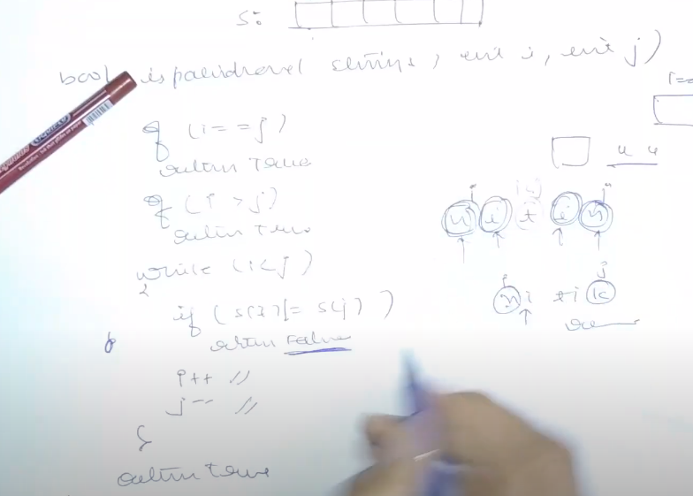

It might be possible that solve(a,I,k) and solve(a,k+1,j) both might not be solved but 1 may.

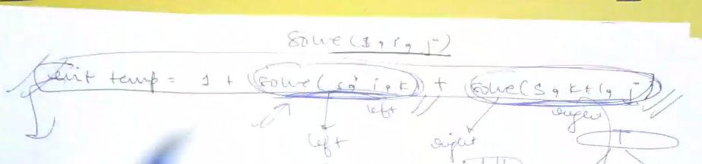

Before writing the above thing we write the following:

Instead of the above 1 line we write the following code.

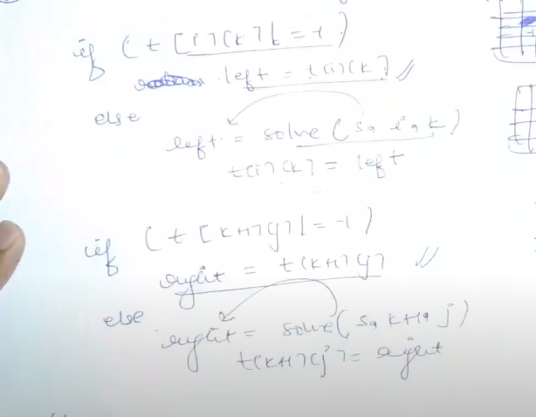

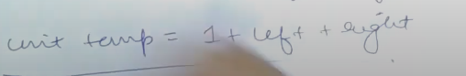

**Evaluate expression true**

This is mcm because we need to apply brackets at a certain position such that the final expression is evaluated to true.

In mcm also we apply brackets so that matrices least cost.

Number of true ways = Left false xor Right true OR Left true xor Right false.

Hence we have to evaluate both false and right number of ways.

Because 4 left false ways and 2 right true ways means 8 ways.

Therefore the function contains 4 arguments.

Step 1: find I and j

I = 0 and j = length()-1.

Step 2: Base condition (smallest valid input or 1st invalid input)

If(I > j)

Return false;

If(i==j)

If(isTrue==’true’)

Return s[i] == ‘T’;

Else

Return s[i] == ‘F’;

Step 3: Move k

For(int k = i+1; k < j; k++)

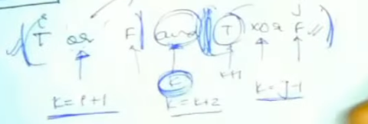

One is from I to k-1 and second is from k+1 to j.

Int lt = solve(s,I,k-1,t)

Int lf = solve(s,I,k-1,f)

Int rt = solve(s,k+1,j,t)

Int rf = solve(s,k+1,j,f)

Step 4: Apply temp

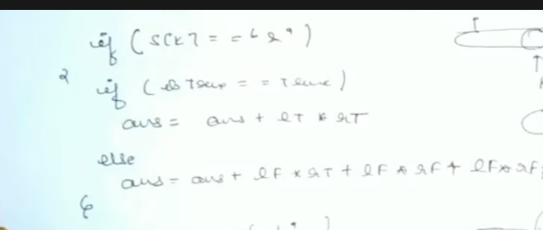

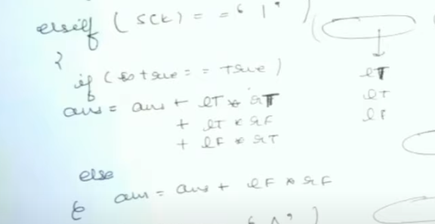

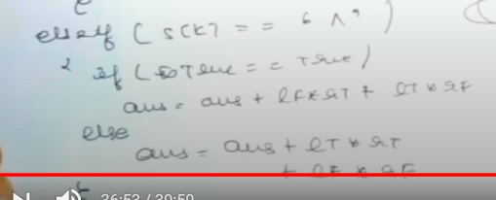

Return ans;

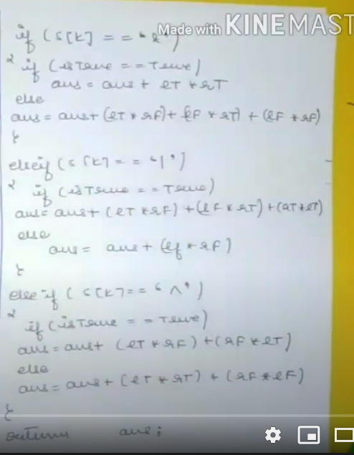

Return mp[temp] = ans // memoization

**Memoization**

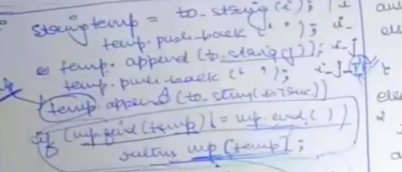

**Scrambled string problem**

The constraints are:

1) There should be no more than 2 child of each child.

2) Each node should either have 2 child or none. It should not be that a node as a single child and an empty string. For example great->gr and eat, but not great and “ “.

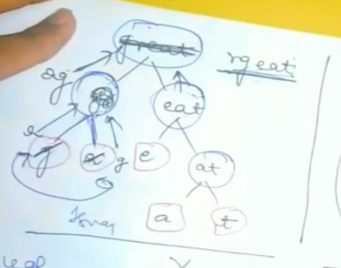

Here 1 swapping is done of g and a, hence gr becomes rg and finally rgeat.

Also here we broke great as gr and eat. We can break from I = 1 to I = n-1 (1 length of last string).

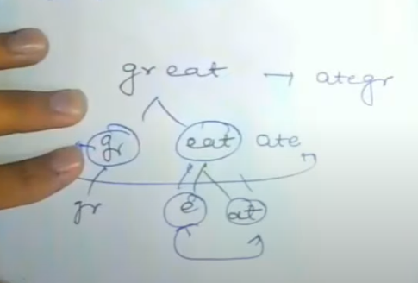

Here great is changed to ategr.

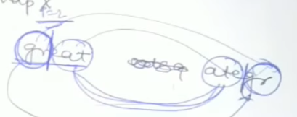

We see from I = 2, the string is swapped as ate and gr.

Further ate and eat is scrambled.

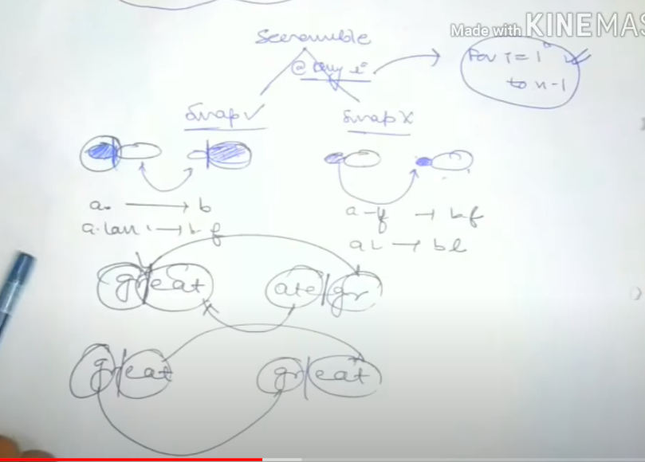

If swapping we first check swap then check scramble.

If no swap we just check for scramble.

Case 1: swapping and scrambling

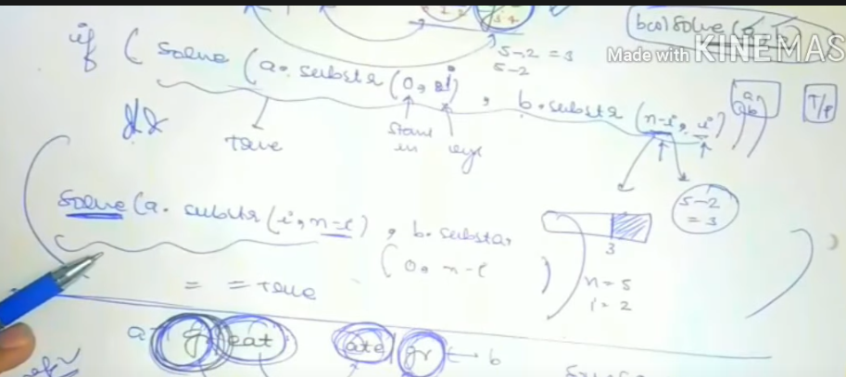

First check for swap, then check that whether the rest string is scrambled or not.

Case 2: scrambling

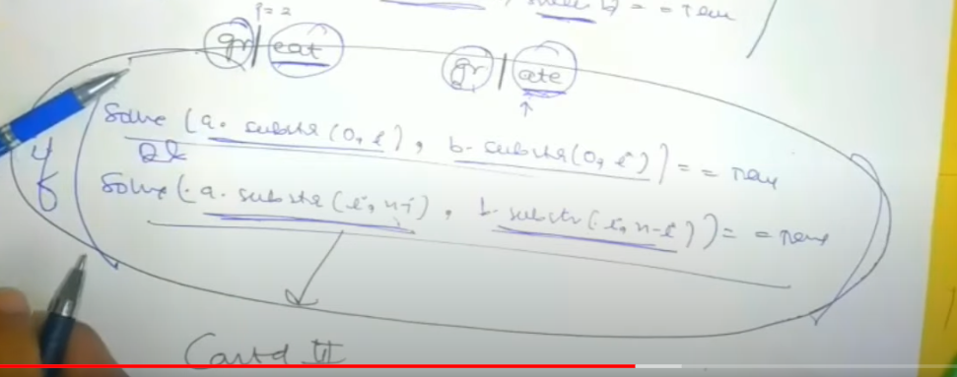

We check for both strings whether they are scrambled or not.

If any of 1 or 2 case is true then yes.

Great

Gr eat

G r ea t

E a

In case 1 first eat is scrambled to ate and the tree becomes

Great

Gr ate

Now gr and ate are swapped.

In case 2 no swapping.

Code

If(a.length() != b.length())

Return false;

If(a.empty() && b.empty())

Return true;

If(a.compare(b) == 0) // both equal

Return true;

**Bool flag is false because we assume its not scrambled**

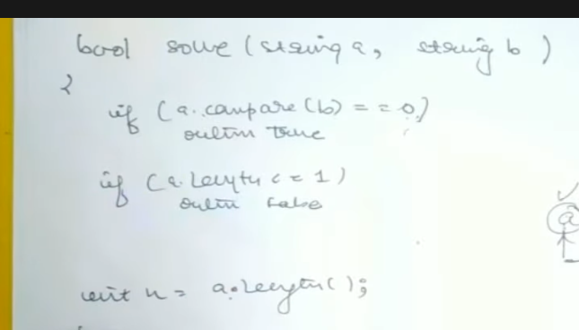

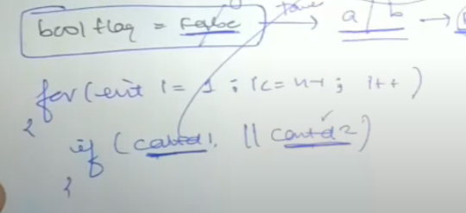

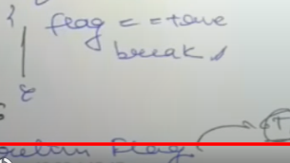

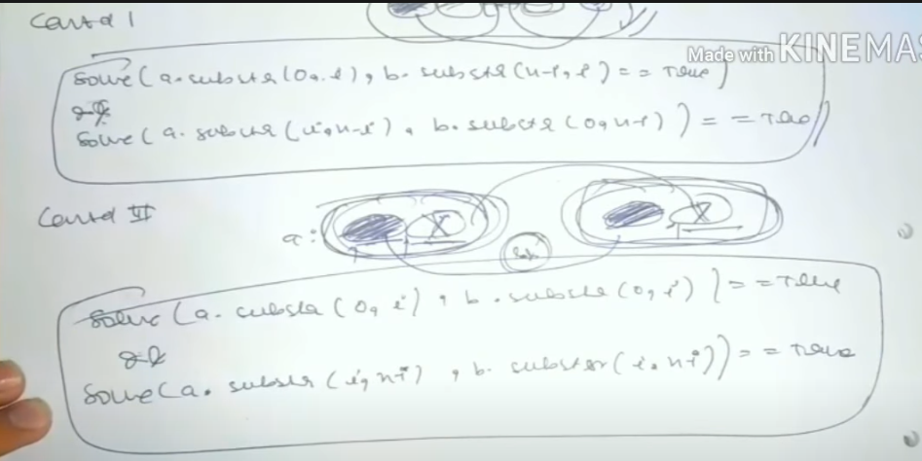

**Recursion**

Use map to store a_b to check if its present.

Unordered_map<string,Boolean> mp;

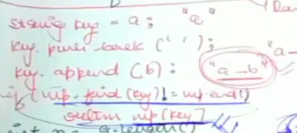

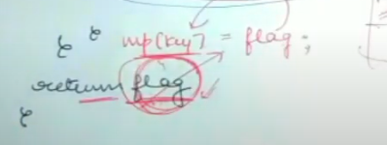

**Egg dropping problem**

We have to find the threshold floor at which egg doesn’t break.

Find number of attempts it takes to find the threshold floor.

In worst case use best techniques to use the 3 eggs to find the threshold floor in min attempts.

Let us say the floor is f from bottom which is threshold.

**Base case**

If we have 1 egg then it will take f turns, so return f. (because we start from bottom and go up, till egg breaks at floor f).

If we have 0 or 1 floor, then 1 attempt.

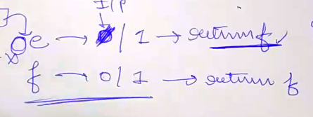

Return f in both case.

Now let us say at a floor k:

1) Egg breaks: solve(e-1,k-1) // because 1 egg is lost and also the threshold floor will obviously be below this floor because egg broke.

2) Egg doesn’t break: solve(e,f-k) // because egg remains

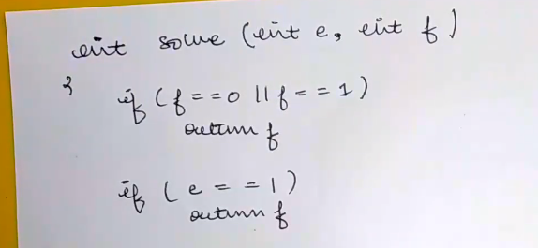

If no floor then we don’t need any number so return f = 0, if f = 1 we need 1 try.

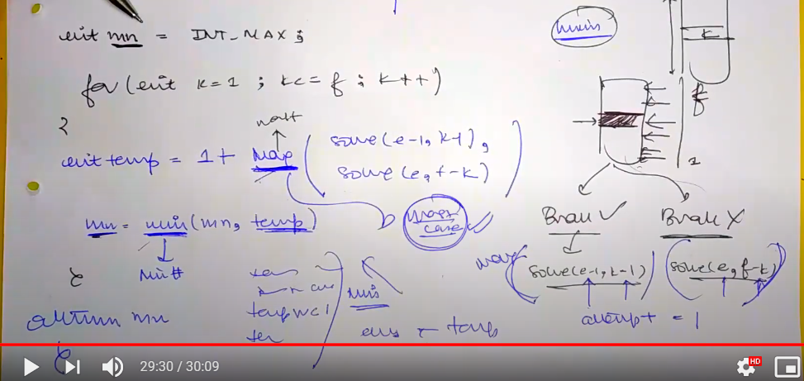

Here we are using max because we need to find for worst case.

We use min because we need to find minimum attempts to get to that worst case floor.

**Memoization**

Int dp[egg+1][floor+1];

Initialise with 0

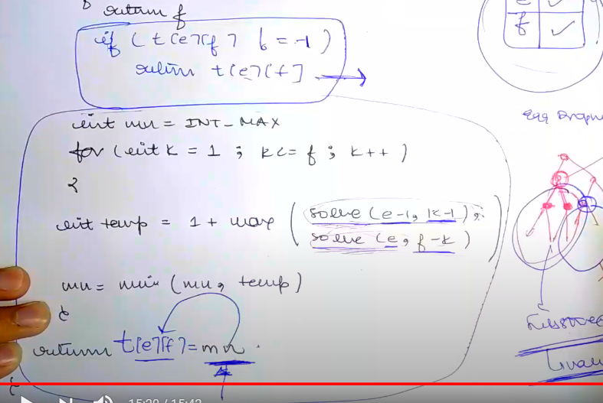

The blue code is memo.

**Additional memo**

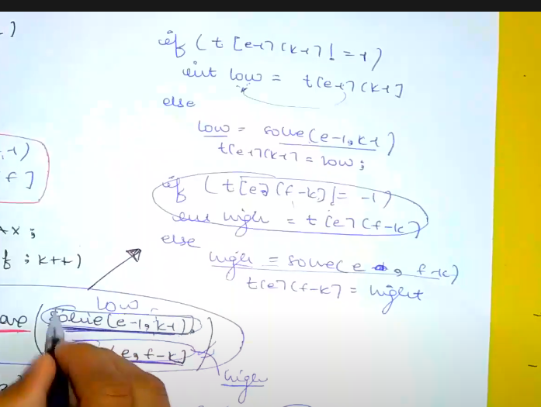

If(t[e-1][k-1] != -1)

Int low = t[e-1][k-1];

Else

Int low = solve(e-1,k-1)

T[e-1][k-1] = low;

If(t[e][f-k] != -1)

Int high = t[e][f-k];

Else

Int high = solve(e,f-k);

T[e][f-k] = high;

**Binary tree**

**Identification**

Whether to apply dp on this tree based question.

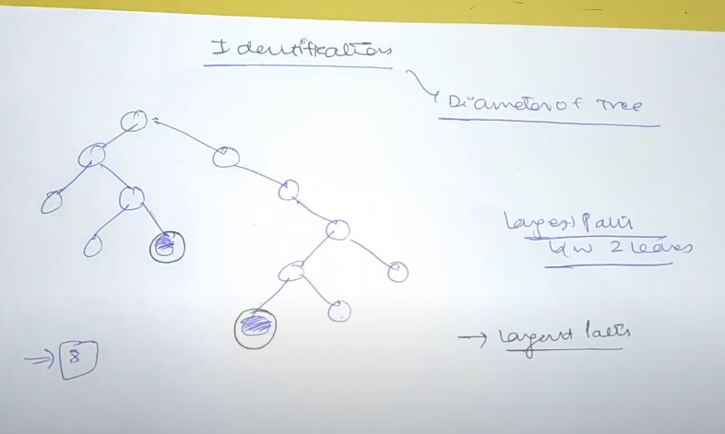

At every node if we find its max left and right tree we can get the diameter.

Hence we see that for every node we have to finds heights so this is repetitive work and use dp.

**General syntax**

Hypothesis will find the ans and we never question it.

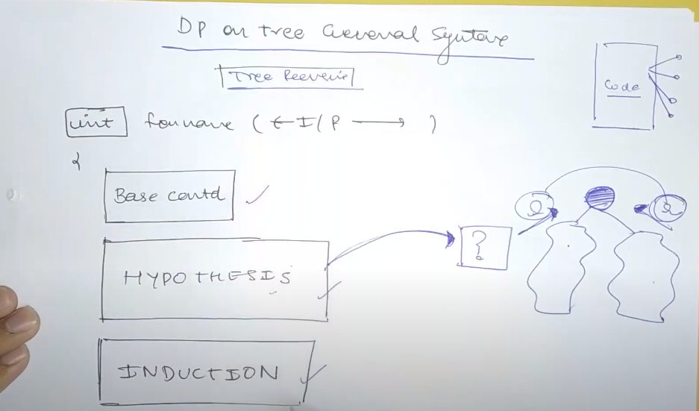

Hypothesis will give us the answer from left and right without question.

Using this left and right we induce the root answer.

Node decide karega ki usko diameter banna hai ya fir ussey apna value pass karna hai kisi upar node ko aur voh fir diameter banega.

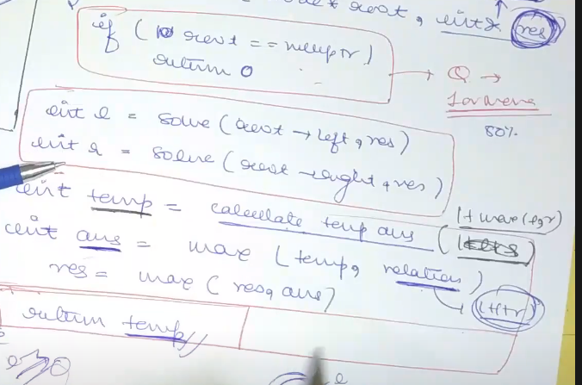

Base condition

Induction step (hypothesis laake left and right ka max dedega and using induction we can calc the value for that root)

Now each node has 2 options. Either it can pass its max value to its above node or itself become the diameter parent node.

If it itself wants to become the node then l+r+1.

If it wants to pass its max then max(l,r) + 1.

Res is passed with & so that it is passed by reference and value is not always changed.

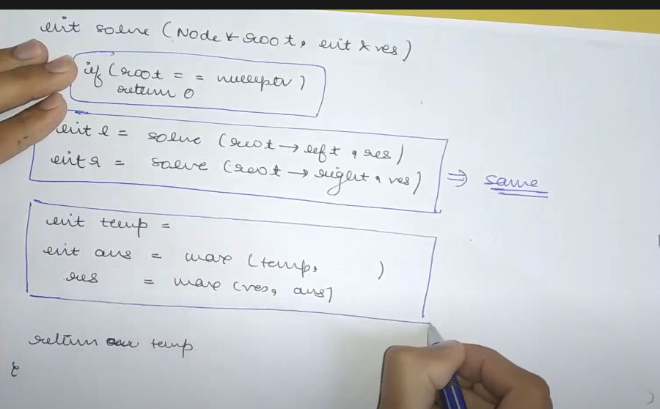

Base, hypothesis remains same, induction which changes.

The changes in induction:

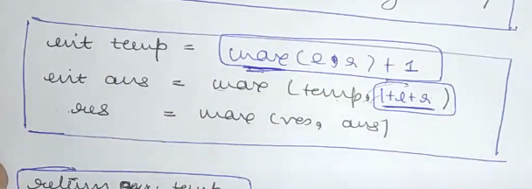

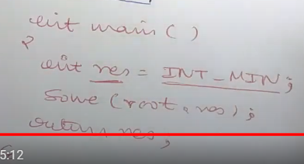

**Maximum path sum (any node to any)**

If a node is negative, we need to be cautious. (we cant include longest diameter)

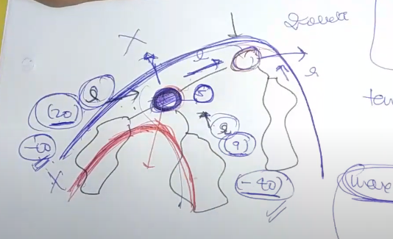

2 cases are possible. Red case where it itself becomes the answer and blue case where it sends some answer to above node/

1) Blue Case

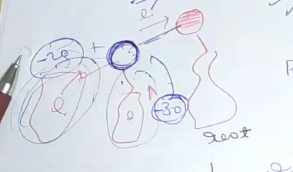

Agar voh blue node ko upar kuch pass karna hai toh uske pass 2 option hai.

Either it can pass its own value (if both of its left and right subtree add up to negative) or it can pass its own value + max (L,R).

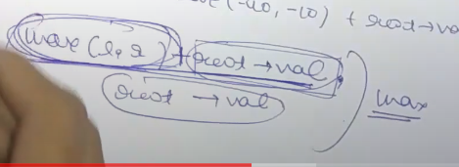

2) Red Case

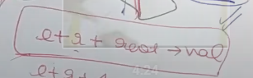

**Code**

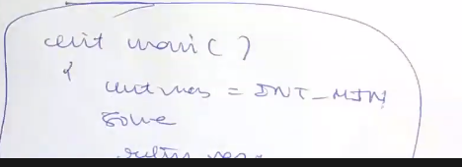

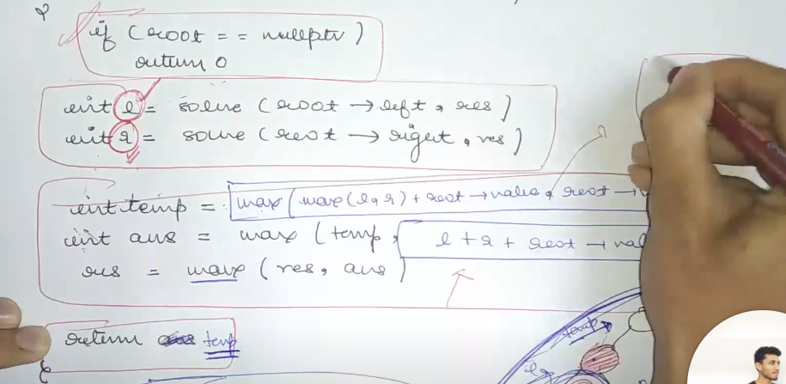

The basic format is same except temp = **AND** ans = .

In Induction

1) Temp = max(max(l,r)+root->val, root->val) // case 1; only root->val is because if left and right is negative

2) Ans = max(temp,l+r+root->val) // case 2; is it itself wants to become the root

**Maximum path (left node to leaf)**

Here case 1 is valid only when the root->val which is being included is leaf (because if both left and right negative then we can only take the case when root was alone if the root is leaf)

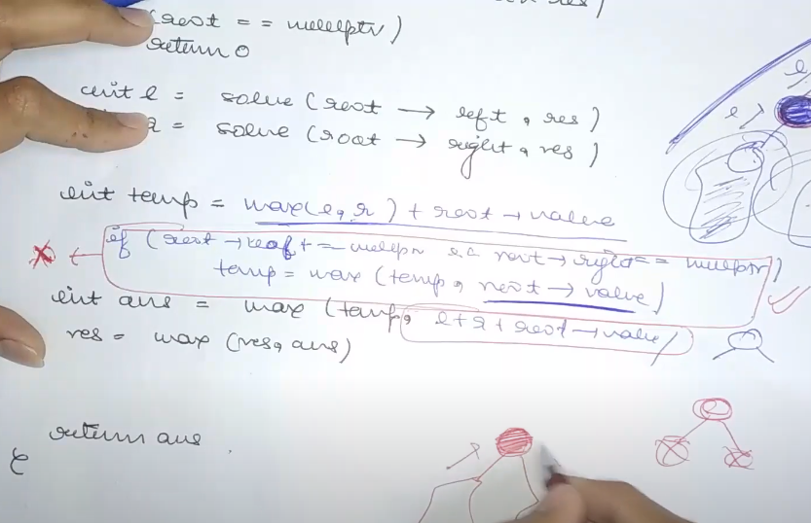

Here we can see in temp = max(l,r) + root->value.

Then if let us say both left and right are negative and we only want to include the root we check if the root is a leaf only then we can take the max of it.